Implementation of Vacuum Cleaner Problem Using Python
Aim
To clean all dirty rooms using a vacuum cleaner agent.
Objective
- To identify dirty and clean rooms.
- To clean dirty rooms using the vacuum cleaner.
- To move between rooms.
- To achieve the goal state where all rooms are clean.
- To understand a simple intelligent agent.
Algorithm
- Start the program.
- Check the current room status.
- If the room is dirty, clean it.
- Move to the next room.
- Repeat the process for all rooms.
- Check whether all rooms are clean.
- If all rooms are clean, stop the program.
- Display the cleaning process and result.
PYTHON CODE:
def vacuum_cleaner(roomA, roomB, location):

if location == 'A':
if roomA == 'Dirty':
print("Cleaning Room A")
roomA = 'Clean'

print("Moving to Room B")

if roomB == 'Dirty':
print("Cleaning Room B")
roomB = 'Clean'

elif location == 'B':
if roomB == 'Dirty':
print("Cleaning Room B")
roomB = 'Clean'

print("Moving to Room A")

if roomA == 'Dirty':
print("Cleaning Room A")
roomA = 'Clean'

print("\nFinal State:")
print("Room A =", roomA)
print("Room B =", roomB)

vacuum_cleaner("Dirty", "Dirty", "A")

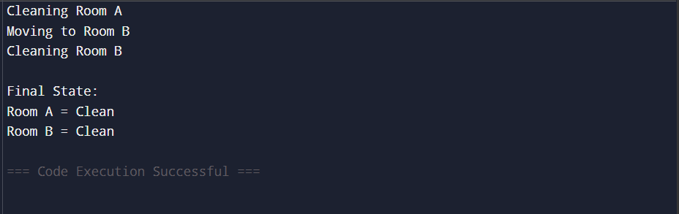
OUTPUT:

FLOW CHART:

Result
Thus, the Vacuum Cleaner Problem was successfully implemented and all rooms were cleaned

